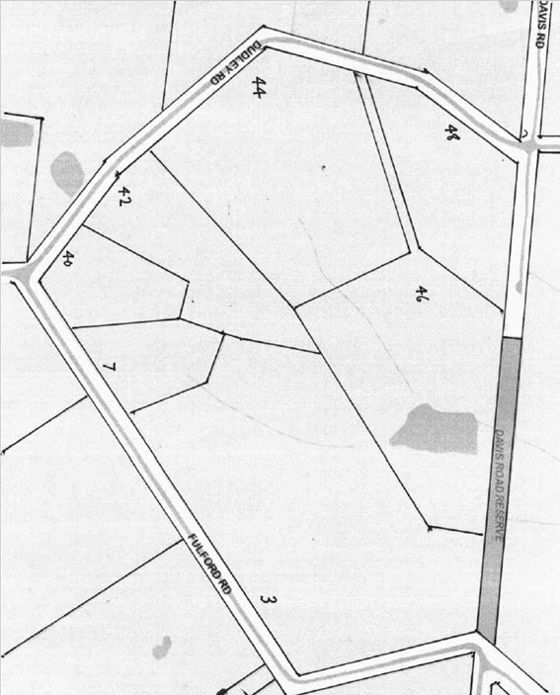**Title History of Crown Allotment 9P Parish of Warrandyte**

15/8/1936 Crown Grant Volume 6937 Folio 311 of 52 acres 2 roods and 37 perches being (Crown) Allotment 9N, for a consideration of Four hundred and seventy-five Pounds **Alfred Kelly** of Wonga Park Assistant Town Clerk became entitled to the land in the Crown Grant and on 20/5/1947 the Crown Grant was sealed.

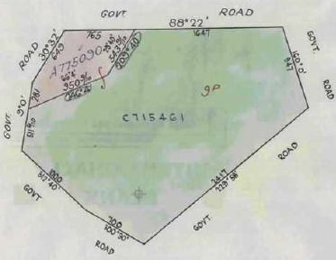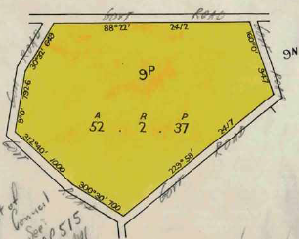10/7/1959 Transmission Application No. A775089. Alfred Kelly died on 24 February 1959. Probate of his Will has been granted to **Inez Freda Frances Kelly** of Wonga Park Widow.

Plan attached to Crown Grant Volume 6937 Folio 311 showing lands transferred out.

Plan of land in Crown Grant Volume 6937 Folio 311

Street Plan for Crown Allotment 9P Parish of Warrandyte

10/7/1959 Transfer as to part No. A775090, area 5 aces 0 roods and 4 perches, new Certificate of Title Volume 8232 Folio 431.

28/2/1967 Transfer as to balance No. C715461, new Certificate of Title Volume 8664 Folio 450.

********************************************************************

**Certificate of Title Volume 8232 Folio 431 Street Address: 48 Dudley Road Wonga Park**

10/7/1959 Certificate of Title Volume 8232 Folio 431, area 5 acres and 4 perches, being part of Crown Allotment 9P (after Transfer No. A775090 from Inez Freda Frances Kelly) issued to (her son) **Richard Frederick Bonynge Kelly** of Wonga Park Municipal Clerk and **Sheena Jessie Cumming** 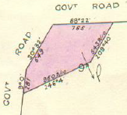of Berwick Spinster.

4/9/1960 Mortgage No. 58969 from Richard Frederick Bonynge Kelly and Sheena Jessie Kelly (formerly Cumming) to Ringwood (No. 7) Co-Operative Housing Society Limited, discharged 17/3/1971.

12/6/1962 Mortgage No. B488224 to The English Scottish and Australian Bank Limited, discharged 17/3/1971.

17/3/1971 Transfer No. D987926 from Richard Frederick Bonynge Kelly and Sheena Jessie Kelly to **John Thompson** Gentleman and **Rosemary Elizabeth Thompson** Married Woman both of 3 Jumping Creek Road Warrandyte.

Plan of land in Certificate of Title Volume 8232 Folio 431

17/3/1971 Mortgage No. D987927 to Bank of New South Wales Savings Bank Limited, discharged 26/11/1976.

28/1/1977 Transfer No. G492921 from John Thompson and Rosemary Elizabeth Thompson to **John Rayden Erle Brook** Journalist and **Elizabeth Catherine Patricia Brook** Married Woman both of 7 Monteith Street Croydon.

11/2/1977 Mortgage No. G510299 to Eastern Suburbs Permanent Building Society Limited. Does not now affect 3/12/1980.

29/11/1977 Caveat No. G882328 lodged. Caveat lapsed 20/11/1980.

23/11/1978 Caveat No. H316494 lodged. Caveat lapsed 20/11/1980.

26/6/1980 Caveat No. J43015 lodged. Caveat lapsed 20/11/1980.

3/12/1980 Transfer No. J257606 from John Rayden Erle Brook and Elizabeth Catherine Patricia Brook to **Theodorus Wilhelmus Homme Van Wegberg** and **Patricia Marie Van Wegberg** Shop Proprietors both of Jumping Creek Road Wonga Park.

3/12/1980 Mortgage No. J257607 to The Commissioners of The State Savings Bank of Victoria.

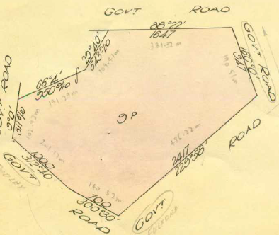15/8/1983 Mortgage No. K503585 to Commonwealth Trading Bank of Australia.

**************************************

**Certificate of Title Volume 8664 Folio 450**

28/2/1967 Certificate of Title Volume 8664 Folio 450, area 47 acres 2 roods and 33 perches, being part of Crown Allotment 9P issued to **Inez Freda Frances Kelly** of “Siwa” Wonga Park Widow.

6/7/1967 Transfer as to part No. C822484, Lot 1, new Certificate of Title Vol. 8675 Fol. 541.

Plan of land in Certificate of Title Volume 8664 Folio 450.

6/4/1976 Certificate of Title Cancelled Pursuant to

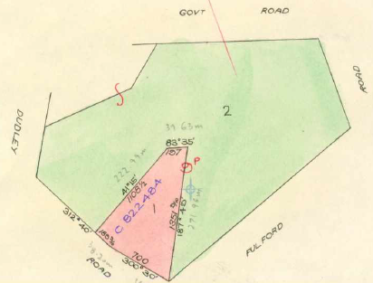Regulation 12 and Titles issued as set out hereunder: Lots One to 2 in Vol 9133 Fol 799 and Vol 9133 Fol 800 – LP 116009.

******************************************

**Certificate of Title Volume 8675 Folio 541**

6/7/1967 Certificate of Title Volume 8675 Folio 541, area 6 acres 1 rood and 7 perches, being Lot 1 on Plan of Subdivision No. 76822 (after Transfer No. C822484 from Inez Freda Frances Kelly) issued to (her son) **Darren Bonynge Kelly** of “Siwa” Wonga Park Secretary Accountant.

Plan attached to Certificate of Title Volume 8664 Folio 450 showing land transferred out.

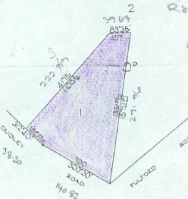17/8/1967 Transfer No. C860192 from Darren Bonynge Kelly to **Darren Bonynge Kelly** of “Siwa” Wonga Park Secretary Accountant and **Andrea Farley Kelly** of “Siwa” Wonga Park Married Woman.

15/9/1967 Mortgage No. C885753 to The Commissioners of The State Savings Bank of Victoria, discharged 3/5/1974.

3/5/1974 Mortgage No. F290581 to The National Bank of Australasia Limited, discharged 18/7/974.

18/7/1974 Mortgage No. F388352 to M & M Nominees Proprietary Limited, discharged 21/7/1977.

4/5/1976 Mortgage No. G131525 to Commonwealth Trading Bank of Australia, discharged 21/7/1977.

Plan of land in Certificate of Title Volume 8675 Folio 541

21/7/1977 Mortgage No. G716424 to M & M Nominees 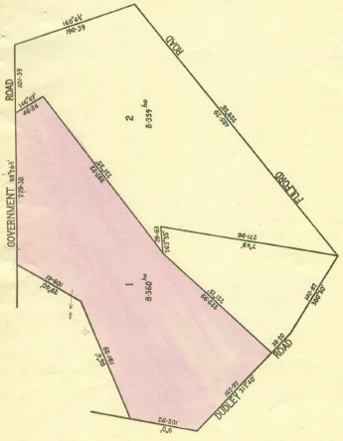Proprietary Limited, discharged 24/3/1992.

28/7/1992 Mortgage No. G725578 to Commonwealth Trading Bank of Australia, discharged 24/3/1992.

24/3/1992 Certificate of Title Cancelled Registration No. R834745H See Vol 10066 Fol 620.

******************************************

**Certificate of Title Volume 9133 Folio 799**

6/4/1976 Certificate of Title Volume 9133 Folio 799, area 8.360 hectares, being Lot 1 on Plan of Subdivision No. 116009 issued to **Inez Freda Frances Kelly** of “Siwa” Wonga Park Widow.

29/5/1986 Transfer No. M296014E to **Richard Frederick Bonynge Kelly** of “River Grange” Ballan.

Plan on Certificate of Title Volume 9133 Folio 799 on which the land in the Title is coloured red and marked”1”

29/5/1986 Mortgage No. M296015B to Inez Freda

Frances Kelly, discharged 30/8/1988.

10/6/1986 Caveat No.M312552U lodged. Caveat withdrawn ?/?/19??.

11/10/1988 Caveat No. N761728B by Darren Bonynge Kelly & Andrea Farley Kelly as Chargee. Caveat transferred to new C/T.

3/4/1990 Certificate of Title Cancelled. The following Titles have been issued Pursuant to Regulation 10 of the Transfer of Land Act: Lots One to 2 in Vol 9942 Fol 219 and in Vol 9942 Fol 220 – LP 217672E.

*******************************************************************

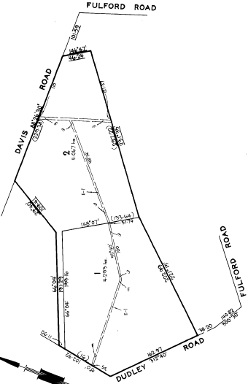**Certificate of Title Volume 9942 Folio 219 Street Address: 44 Dudley Road Wonga Park**

3/4/1990 Certificate of Title Volume 9942 Folio 219, area 4.293 hectares, being Lot 1 on Plan of Subdivision No. 217672E issued to **Richard Frederick Bonynge Kelly** of “River Grange” Ballan.

22/7/1985 Caveat No. N761728B by Darren Bonynge Kelly & Andrea Farley Kelly as Chargee.

9/11/1998 Withdrawal No. V734907C of Caveat (No. N761728B) lodged.

9/11/1998 Transfer No. V734908Y from Richard Frederick Bonynge Kelly to **Deb Holdings Pty. Ltd.** of 7/35 John St. Lower Templestowe 3107.

Plan on Certificate of Title Volume 9942 Folio 219 on which the land in the Title is marked “1”.

5/10/2000 Transfer No. X077499A from Deb Holdings Pty. Ltd. to **Graeme John Clementson** and **Susan Louise Clementson** both of 44-46 Dudley Rd. wonga park 3115.

5/10/2000 Mortgage No. X077500N to Commonwealth Bank of Australia lodged.

***********************

**Certificate of Title Volume 9942 Folio 220**

3/4/1990 Certificate of Title Volume 9942 Folio 220, area 4.627 hectares, (No C of T exists – perhaps lost) but presumably issued to **Richard Frederick Bonynge Kelly** of “River Grange” Ballan.

Plan on Certificate of Title Volume 9942 Folio 220 on which the land in the Title is marked “2”.

9/2/1999 Transfer No. V882974X from Richard Frederick Bonynge Kelly as Tenants in Common as to 1 of a total of 2 equal undivided shares to **Crispin Catering Pty ltd** of 33 Lynette Av. Warrandyte 3113 and as to 1 of a total of 2 equal undivided shares to **Angus Bonynge Kelly** of 30 John St. Elwood 3184.

12/9/2003 Mortgage No. AC329796F to Bank of Western Australia Ltd.

9/2/2004 Agreement No. AC653327J (under) Section 173 Planning and Environment Act 1987.

*****************************************************************************

**Certificate of Title Volume 9133 Folio 800**

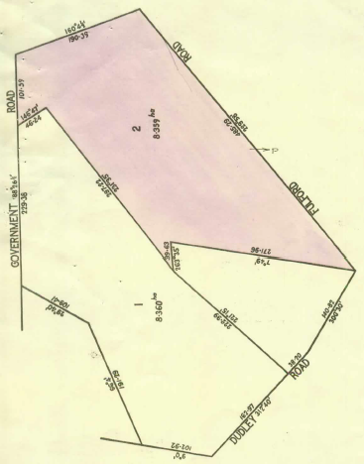6/4/1976 Certificate of Title Volume 9133 Folio 800, area 8.359 hectares, being Lot 2 on Plan of Subdivision No. 116009 issued to **Inez Freda Frances Kelly** of “Siwa” Wonga Park.

19/5/1976 Caveat No. G154479 lodged. Caveat will lapse on registration of J915336 19/5/1982.

5/5/1982 Transfer No. J915336 from Inez Freda Frances Kelly to (her son) **Darren Bonynge Kelly** Accountant and **Andrea Farley Kelly** Married woman both of “Kellybrook” Dudley Road Wonga Park.

5/5/1982 Mortgage No. J915337 to M. & M. Nominees Proprietary Limited.

11/10/1982 Caveat No. K117393 lodged. Caveat withdrawn 30/8/1988.

Plan on Certificate of Title Volume 9133 Folio 800on which the land in the Title is coloured red and marked “2”.

10/6/1986 Caveat No. M312553 lodged. Caveat transferred to new C/T.

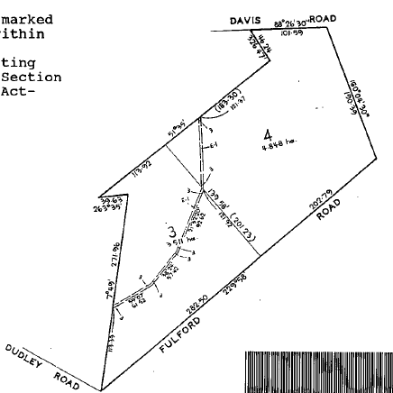4/11/1991 Certificate of title Cancelled. The following titles have been issued Pursuant to Regulation 10 of the Transfer of Land Act: Lots 3 to4 in Vol 10042 Fol 685 (and) in Vol 10042 Fol 686 – LP 214511W.

*****************************************

**Certificate of Title Volume 10042 Folio 685**

4/11/1991 Certificate of Title Volume 10042 Folio 685, area 3.511 hectares, being Lot 3 on Plan of Subdivision No. 215411W issued to **Darren Bonynge Kelly** and **Andrea Farley Kelly** both of Dudley Road Wonga Park subject to Mortgage No. J915337 to M. & M. Nominees Proprietary limited.

Plan on Certificate of Title Volume 10042 Folio 685 on which the land in the Title is marked “3”.

10/6/1986 Caveat No. M312553R by Richard Bonynge Kelly as Chargee. Caveat withdrawn 24/3/1992.

16/8/1989 Mortgage No. P375602R to M. & M. Nominees Proprietary Limited, discharged 24/3/1992.

24/3/1992 Mortgage No. R834760Q to M. & M. Nominees Pty. Ltd.

24/3/1992 Mortgage No. 834863A to Commonwealth Bank of Australia.

18/6/1992 Certificate of Title Cancelled as to Part Pursuant to Section 24 Subdivision Act 1988 and Titles issued as set out hereunder Lot 5 in Vol 10071 Fol 511 – PS 308647B.

18/6/1992 Certificate of Title Cancelled as to Balance Pursuant to Section 24 Subdivision Act 1988 and Titles issued as set out hereunder Lots 3 to 4 in Vol 10071 Fol 512 to Vol 10071 Fol 513 – PS 312187R.

**Certificate of Title Volume 10071 Folio 511 Street Address: 40 Dudley Road Wonga Park**

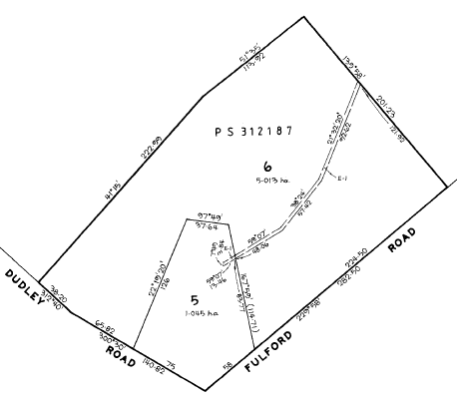18/6/1992 Certificate of Title Volume 10071 Folio 511, area 1.045 hectares, being Lot 5 on Plan of Subdivision No. 308647G derived from Certificates of Title Volume 10042 Folio 685 and Volume 10066 Folio 620 issued to **Darren Bonynge Kelly** and **Andrea Farley Kelly** both of “Kellybrook Winery” Fulford Road Wonga Park subject to Mortgages No. R834760Q to M & M Nominees Pty. Ltd. and No. R834863A to Commonwealth Bank of Australia which Mortgages were discharged 9/11/1992.

9/11/1992 Transfer No. S207037P from Darren Bonynge Kelly and Andrea Farley Kelly to **David Sutherland** and **Jennifer Blanche Sutherland** both of 11 Dunlop Street Kew.

9/11/1992 Mortgage (in priority ranking) No. S207038L to National Australia Bank Limited.

Plan of Subdivision No. 308647G on which the land in Certificate of Title Volume 10042 Folio 685 is marked “5”.

9/2/1999 Discharge No. V884345C of Mortgage No. S207038L lodged.

9/2/1999 Transfer No. V884346Y from David Sutherland and Jennifer Blanche Sutherland to **Jennifer Blanche Sutherland** of “Doonside” Dudley Rd. Wonga Park 3115.

9/2/1999 Mortgage No. V884347V to Perpetual Trustees Australia lodged.

4/1/2018 Discharge No. AQ605235P of Mortgage No. V884347V lodged.

4/1/2018 Transfer No. AQ605236M from Jennifer Blanche Sutherland to **Jason John McGrath** and **Guoyu Zu** both of 40 Dudley Road Wonga Park Vic 3115.

4/1/2018 Mortgage No. AQ605237K to Commonwealth Bank of Australia lodged.

***********************************************************************

**Certificate of Title Volume 10071 Folio 512 Street Address: 42 Dudley Road Wonga Park**

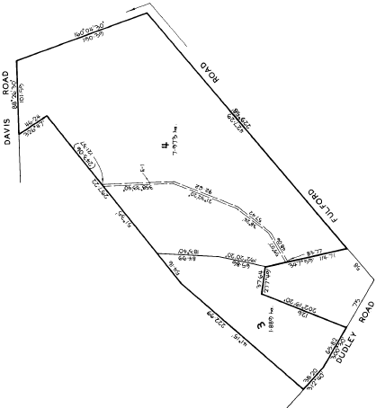18/6/1992 Certificate of Title Volume 10071 Folio 512, area 5.013 hectares, being Lot 3 on Plan of Subdivision No. 312187R (derived from Certificates of Title Volume 10042 Folios 685 and 686 and Volume 10066 Folio 620) issued to **Darren Bonynge Kelly** and **Andrea Farley Kelly** both of “Kellybrook Winery” Fulford Road Wonga Park subject to Mortgages No. R834760Q to M & M Nominees Pty. Ltd. and No. R834863A to Commonwealth Bank of Australia both of which Mortgages were discharged 11/11/1993.

11/11/1993 Mortgage No. S785310 to National Australia Bank Limited, discharged as to part being the within land 20/5/1994.

20/5/1994 Transfer No. T98736M from Darren Bonynge Kelly and Andrea Farley Kelly to as tenants in common in equal shares to **Wesley Raymond Taylor, Louise Maria Taylor, Gordon Lindsay Taylor & Diane Marjorie Taylor** all of 40 Dudley Rd. Wonga Park.

Plan of Subdivision No. 312187R on which the land in Certificate of Title Volume 10071 Folio 512 is marked “3”.

20/5/1994 Mortgage No. T98737J to Australia and New Zealand Banking Group Limited.

20/5/1994 Mortgage No. T98738F to Australia and New Zealand Banking Group Limited.

27/2/1997 Transfer No. U658023H from Wesley Raymond Taylor, Louise Maria Taylor, Gordon Lindsay Taylor & Diane Marjorie Taylor to **Wesley Raymond Taylor** and **Louise Maria Taylor** both of 40 Dudley Rd. Wonga Park.

27/2/1997 Mortgage No. U658024E to Australia and New Zealand Banking Group Limited lodged.

8/5/2003 Discharge No. AC049106V of Mortgages Nos. T098737J, T098738F and U658024E lodged.

8/5/2003 Mortgage No. AC049107T to Perpetual Trustees Victoria Limited lodged.

26/7/2005 Caveat No. AD771809V by Equity-One finance & Investments Pty Ltd as Chargee lodged.

29/7/2005 Caveat No. AD780852T by Crane Distribution Limited as Chargee lodged.

5/2/2007 Caveat No. AE878628V by John Humphries as Mortgagee lodged.

7/2/2007 Caveat No. AE885426T by Mestika Group Pty. Ltd. as Chargee lodged.

27/6/2007 Caveat No. AF161351D by Mark Schaub and Gayle Brenda Schaub as Purchasers lodged.

4/9/2007 Transfer by Mortgagee/Chargee from Wesley Raymond Taylor and Louise Maria Taylor to **Mark Schaub** and **Gayle Brenda Schaub** both of 42 Dudley Road Wonga Park Vic 3115 and the Removal of Mortgage No. AC049107T and the Lapsing of Caveats Nos. AD771809V, AD781852T, AE878628V, AE8845426T and AF161351D.

4/9/2007 Mortgage No. AF314997C to Maroondah Credit Union Ltd lodged.

31/10/2010 Discharge No. AH465155R of Mortgage No. AF314997C lodged.

31/8/2010 Mortgage No. AH465156P to Commonwealth Bank of Australia lodged.

18/8/2021 Caveat No. AU706959V by Chin Fong Lee and Lay Bee Ng as Purchasers lodged.

19/11/2021 Discharge No. AV037122A of Mortgage No. AH465156P lodged.

19/11/2021 Withdrawal No. AV037123X of Caveat No. AU706959V lodged.

19/11/2021 Transfer No. AV037124V from Mark Schaub and Gayle Brenda Schaub to **Lay Ng** and **Chin Fong Lee** both of 42 Dudley Road Wonga Park Vic 3115.

20/8/2024 Survivorship Application No. AY324688U by **Lay Ng** of 42 Dudley Road Wonga Park Vic 3115.

****************************************************************************

**Certificate of Title Volume10071 Folio 513**

18/6/1992 Certificate of Title Volume10071 Folio 513, area 7.973 hectares, (No C of T exists – perhaps lost) being Lot 4 on Plan of Subdivision No. 312187R issued to **Darren Bonynge Kelly** and **Andrea Farley Kelly** both to “Kellybrook Winery” Fulford Rd. Wonga Park.

18/1/2003 Mortgage No. AB819909W to Bank of Western Australia Ltd.

9/2/2004 Agreement No. AC653327J under Section 173 Planning and Environment Act 1987.

9/3/2005 Certificate of Title Cancelled re lots 2 to 4 on Plan of Subdivision No. 501183F See Vol. 10861 Fol. 779 to Vol. 10861 Fol. 781.

Plan of Subdivision No. 312187R on which the land in Certificate of Title Volume 10071 Folio 513 is marked “4”.

*************************************************************************

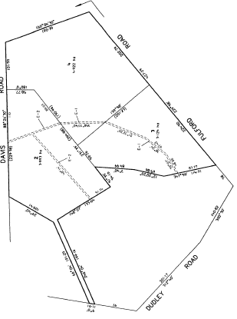**Certificate of Title Volume 10861 Folio 779 Street Address: 46 Fulford Road Wonga Park**

9/3/2005 Certificate of Title Volume 10861 Folio 779, area 3.993 hectares, being Lot 2 on Plan of Subdivision No.512283F (derived from Certificates of Title Volume 9942 Folio 220 and Volume 10071 Folio 513) issued to as Tenants in Common as to 1 of a total of 2 equal undivided shares to **Crispin Catering Pty Ltd** of 33 Lynette Av. Warrandyte 3113 and as to 1 of a total of 2 equal undivided shares to **Angus Bonynge Kelly** of 30 John St. Elwood 3184 subject to Mortgage No. AC329796F to Bank of Western Australia and Agreement No. AC653327J under Section 173 Planning and Environment Act 1987.

Plan of Subdivision No. 512283F on which the land in Certificate of Title Volume 10861 Folio 779 is marked “2”.

15/9/2006 Discharge No. AE609770X of Mortgage No. AC329796F lodged.

15/9/2006 Transfer No. AE609771V from Crispin Catering Pty Ltd and Angus Bonynge Kelly to as Tenants in Common as to1 of a total of 2 equal undivided shares as sole proprietor to **Crispin Catering Pty. Ltd.** of Kellybrook Winery Fulford Road Wonga Park Vic 3115 and as to 1 of a total of 2 equal undivided shares as joint proprietors to **Philip Bonynge Kelly** and **Jennifer Ruth Kelly** both of Kellybrook Winery Fulford Road Wonga Park Vic 3115.

15/9/2006 Mortgage No. AE609772T to Bank of Western Australia Ltd lodged.

2/8/2018 Discharge No. AR310256Q of Mortgage No.AE609772T lodged.

2/8/2018 Mortgage No. AR310257N to Commonwealth Bank of Australia lodged.

*********************

**Certificate of Title Volume 10861 Folio 780**

9/3/2005 Certificate of Title Volume 10861 Folio 780, area 3.124 hectares, being Lot 3 on Plan of Subdivision No. 512283F (derived from Certificates of Title Volume 9942 Folio 220 and Volume 10071 Folio 513) issued to **Darren Bonynge Kelly** and **Andrea Farley Kelly** both of “Kellybrook Winery” Fulford Rd. Wonga Park subject to Mortgage No. AB819909W to Bank of Western Australia Ltd and Agreement No. AC653327J under Section 173 Planning and Environment Act 1987.

Plan of Subdivision No. 512283F on which the land in Certificate of Title Volume 10861 Folio 780 is marked “3”.

17/6/2022 Removal No. AV751674Y of Section 173 Agreement No. AC653327J lodged.

19/12/2022 Certificate of Title Cancelled by Plan of Subdivision No. 836895P.

**Certificate of Title Volume 10861 Folio 781**

9/3/2005 Certificate of Title Volume 10861 Folio 781, area 4.922 hectares, being Lot 4 on Plan of Subdivision No. 512283F (derived from Certificates of Title Volume 9942 Folio 220 and Volume 10071 Folio 513) issued to **Darren Bonynge Kelly** and **Andrea Farley Kelly** both of “Kellybrook Winery” Fulford Rd. Wonga Park Vic 3115 subject to Mortgage as to part No. AB819909W to Bank of Western Australia Ltd.

??/??/20?? Certificate of Title Cancelled See Certificates of Title Volume 12451 Folio 932 to Volume 12451 Folio 933 – Lots A and B on Plan of Subdivision No. 836895P.

Plan of Subdivision No. 512283F on which the land in Certificate of Title Volume 10861 Folio 780 is marked “4”.

*************************************

**Certificate of Title Volume 12451 Folio 933 Street Address: 3 Fulford Road Wonga Park**

2/2/2023 Certificate of Title Volume 12451 Folio 933, area 7.044 hectares, being Lot A on Plan of Subdivision No. 836895P (derived from Certificates of Title Volume 10861 Folio 780 and Volume 10861 Folio 781) issued to **Darren Bonynge Kelly** and **Andrea Farley Kelly** both of 1-3 Fulford Rd. Wonga Park Vic 3115 subject to Mortgage as to part No. AB819909W to Bank of Western Australia Ltd.

**********************************

**The Street Address for Lot B on Plan of Subdivision No. 836895P is 7 Fulford Road Wonga Park.**

Plan of Subdivision No. 512283F on which the land in Certificate of Title Volume 10861 Folio 780 is marked “4”.