**History of Part of Crown Section 13 Parish Warrandyte – Lyons Road**

1/11/1911 Certificate of Title Volume 3468 Folio 421, area 15 acres 2 roods and1 perch being part of Crown Section 13 at Croydon in the Parish of Warrandyte and originally granted to Thomas Whitaker by Grant dated 5/1/1855 issued to **John Ahern** Parish of Warrandyte County of Evelyn Farm Servant subject to Any adverse possession of the land and the interest of any tenant or occupier thereof (and subject to) The right (if any) to dower of the respective wives of Thomas Whitaker described above of Collingwood and James … of Warrandyte Farmer and of Heather? McBride Dunlop of Warrandyte Police Constable The second encumbrance notified above has been honoured 16/12/1912. It appears that prior to this Certificate of Title the land was under a General Law Title, brought under the Transfer of Land Act in Application No. 38205.

Map showing property boundaries included in this part of Crown Section 13 Parish of Warrandyte

25/10/1912 Memo No. 5200. John Ahern died on the 12 day of October 1888. On the 29yth day of May 1980 probate of the will of the said John Ahern was granted to **Thomas Duggan** of Mooralbark (sic) Farmer and **David Bilcock** of Birts Hill Croydon Storekeeper as executors. The said David Bilcock died on the 14th day of September 1910, the said Thomas Duggan having predeceased him. On the 6th day of April 1911 probate of the will was granted to **Mary Ann Bilcock** as executrix.

Plan of land in Certificate of Title Volume 85 Folio 973.

4/12/1914 Transfer No.701549 from Mary Ann Bilcock to **Patrick Lyons** of Croydon Farmer and **John Thomas Lyons** of York Street Richmond Constable of Police.

14/5/1921 Transfer No.765221, from Patrick Lyons and John Thomas Lyons to **Michael Lyons** ofEast Trentham Hotel Keeper.

18/2/1919 Transfer No. 878401 from Michael Lyons to **Denis Bowes Daly**, new Certificate of Title Volume 4190 Folio 873.

**********************************************************************

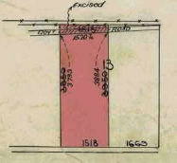**Certificate of Title Volume 4190 Folio 873**

18/2/1919 Certificate of Title Volume 4190 Folio 873, area 59 acres 1 rood and 2 perches, being part of Crown Section 13 after Transfer No. 878401from Michael Lyons issued to **Denis Bowes Daly** of Croydon Gentleman.

12/11/1926 Transfer No. 1293190 to **The President Councillors and Ratepayers of the Shire of Lillydale**, area 3 aces 3 roods and 9.8 perches, new Certificate of Title Volume 5200 Folio 875. This land would be Lyons Road.

6/7/1928 Red Ink No. 2935232. Denis Bowes Daly died on 11th November 1927. Probate has been granted to **Rebecca Daly** of Croydon widow.

Plan of land in Certificate of Title Volume 4190 Folio 873.

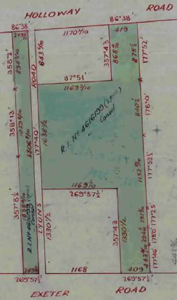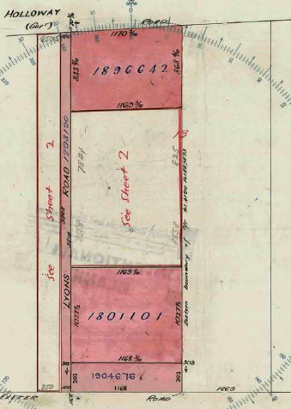14/1/1941 Transfer as to part No. 1801101 to John Leslie McDonald, new Certificate of Title Volume 8611 Folio177, area 12 acres 0 roods and 1perch.

8/10/1943 Transfer as to part No. 1896642 to Walter Neil Chambers, new Certificate of Title Volume 6664 Folio 738, area 10 acres 0 roods and 2 perches.

Plan attached to Certificate of Title Volume 4190 Folio 873 showing balance of land in the Title consolidated with the land in Certificate of Title Volume 4190 Folio 874

Plan attached to Certificate of Title Volume 4190 Folio 873 showing lands transferred out as to part.

10/1/1944 Transfer as to part No. 1904676 to Douglas Ronald William Wilson. New Certificate of Title Volume 6675 Folio 827, area 3 acres 2 roods and 6 perches.

4/5/1944 Caveat No. 113331 lodged. Caveat withdrawn 6/3/1946.

26/8/1948 Red Ink No. 4616199. Certificate of Title Cancelled, new Certificate of Title Volume 7345 Folio 811.

*************************************************************************

**Certificate of Title Volume 3840 Folio 903**

23/1/1915 Certificate of Title Volume 3840 Folio 903, area 15 acres 1 rood and 8 perches, being part of Crown Section 13 Parish of Warrandyte County of Evelyn issued to **Michael Lyons** of East Trentham in the County of Dalhousie Licensed Victualler subject to 1. The Special Railway Conditions contained in Grant to Thomas Whittaker and 2. The Rights of parties under the Intestacy of William Lyons who died on 2nd February 1912 and Letters of Administration of whose estate were granted to Michael Lyons on 2nd April 1912. It appears that prior to this Certificate of Title the land was under a General Law Title, brought under the Transfer of Land Act in Application No. 40474.

Plan of land in Certificate of Title Volume 3840 Folio 903

18/2/1919 Transfer No. 878401 from Michael Lyons to Denis Bowes Daly, new Certificate of Title Volume 4190 Folio 874.

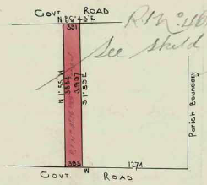 ****************************************************************************

**Certificate of Title Volume 4190 Folio 874**

18/2/1919 Certificate of Title Volume 4190 Folio 874, area 15 acres 1 rood and 8 perches, being part of Crown Section 13 after Transfer No. 878401from Michael Lyons issued to **Denis Bowes Daly** of Croydon Gentleman.

6/7/1928 Red Ink No. 2935232. Denis Bowes Daly died on 11th November 1927. Probate has been granted to **Rebecca Daly** of Croydon widow.

26/8/1948 Red Ink No. 4616199. Certificate of Title Cancelled see Certificate of Title Volume 7345 Folio 811.

Plan of land in Certificate of Title Volume 4190 Folio 874.

*************************************************************************

**Certificate of Title Volume 7345 Folio 811**

26/8/1948 Certificate of Title Volume 7345 Folio 811, area 46 acres and 6 perches, being parts of Crown Section 13 issued to **Rebecca Daly** of Croydon Widow.

16/3/1950 King’s Caveat No. 121411 lodged. King’s Caveat withdrawn 25/9/1950.

3/8/1948 Transfer as to part No. 1990556 to William Lindsay Park, new Certificate of Title Volume 7498 Folio 005, area 10 acres 0 roods and 0 perches.

31/8/1948 Transfer as to part No. 1996692 to Arthur Jones, new Certificate of Title Volume 7496 Folio 130, area 9 acres 1 rood and 25 perches.

13/4/1949 Transfer as to part No. 2208947 to William Manfred Wilson, new Certificate of Title Volume7496 Folio 129.

25/9/1950 Red Ink No. 4947073. Rebecca Daly who was executrix of the Will of Denis

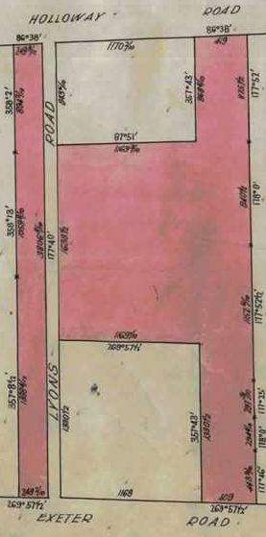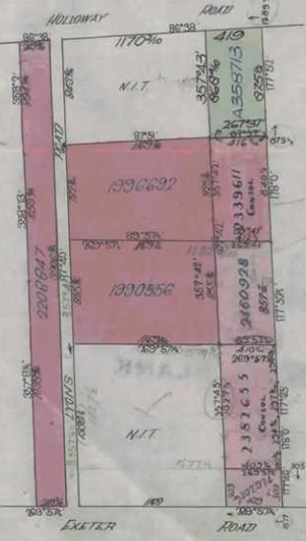Bowes Daly died on 11th November 1927 died on 27th February 1950. Probate of her Will has been granted to **Robert O’Hara Birmingham** Gentleman and **George Thomas Henry Swindon** Bank Manager both of Hull Road Croydon.

1/11/1950 Transfer as to part No. 2339611 to Marcus John Macartney, new Certificate of Title Volume 7498 Folio 006, ~~area 10 acres 3 roods and 17½ perches~~.

Plan attached to Certificate of Title Volume 7345 Folio 811 showing the lands transferred out.

Plan of land in Certificate of Title Volume 7345 Folio 811

29/11/1950 Transfer as to part No. 2382655 to Keith Francis Cook and Robert Thomas McKnight, new Certificate of Title Volume 7498 Folio 012.

17/8/1951 Transfer as to part No. 2402974 to Harold Creighton, new Certificate of Title Volume 7606 Folio 105, area 1 acre 0 roods and 36 perches.

11/12/1951 Transfer as to part No. 2460928 to William Lindsay Park, new Certificate of Title Volume 7714 Folio 161.

26/6/1957 Transfer as to balance No. A358713, new Certificate of Title Volume 8158 Folio 379.

I cannot be sure, but I suspect that the lands transferred out of the title on the east side of the land abut Karingal Street, otherwise 3 of them would not have a street frontage.

************************************************************************

**Certificate of Title Volume 7496 Folio 129**

13/4/1949 Certificate of Title Volume 7496 Folio 129, being part of Crown Section 13 issued to **William Manfred Wilson** of Exeter Road Croydon North.

24/11/1950 Transfer as to part No. 2271896 to Thora Victoria Clark, new Certificate of Title Volume 7498 Folio 007 (Lots 33 to 35 PS 20045).

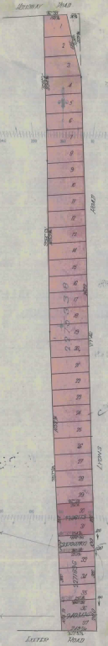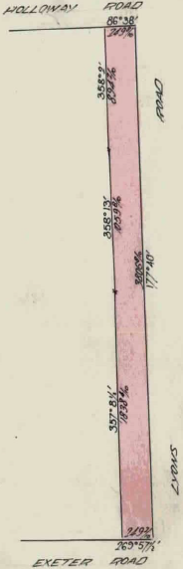24/11/1950 Transfer as to part No. 2275338 to Albert Arthur Jacobs, new Certificate of Title Volume 7498 Folio 009 (Lots 1 to 29 PS 20045).

24/11/1950 Transfer as to part No. 2298173 to Clarence William Simpson, new Certificate of Title Volume 7498 Folio 011 (Lots 30 and 31 PS 20045).

14/12/1950 Transfer as to part No. 2370074 to Elsie May Hannaby, new Certificate of Title Volume 7567 Folio 001 (Lot 32 PS 20045).

30/5/1951 Transfer as to Part No. 2403126 to Douglas Ronald William Wilson, new Certificate of Title Volume 7567 Folio 002 Lots 36 and 37 PS 20045).

12/4/2017 Recording of disposition of land No. AV742420D from William Manfred Wilson to Maroondah City Council of Braeside Avenue Ringwood Vic 3134 (Road R1 on PS 20045).

Right: Plan of land attached to Certificate of Title Volume 7496 Folio 129 showing lots on Plan of subdivision No. 20045 and the lands transferred out.

Left: Plan of land in Certificate of Title Volume 7496 Folio 129

**Certificate of Title Volume 7498 Folio 009**

24/11/1950 Certificate of Title Volume 7498 Folio 009, area 7 acres 2 roods and 15 perches, being Lots One to 29 (both inclusive) issued to **Albert Arthur Jacobs** of 23 Grovedale Road Surrey Hills Surveyor Chainman subject to The Covenant contained in Instrument of Transfer No. 2275338.

Plan of land in Certificate of Title Volume 7498 Folio 009

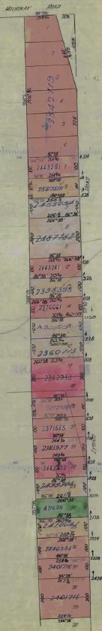24/11/1950 Transfer as to part No. 2287108 to Agnes Ellen Hall and William Henry Hall, new Certificate of Title Volume7498 Folio010 (Lot 19).

18/4/1951 Caveat No.124385 affecting part of the land herein. Caveat lapsed 21/11/1955.

28/2/1951 Transfer as to part No. 2383977 to Seddon Morrison Kerr and Lilian Kerr, new Certificate of Title Volume 7563 Folio 020 (Lot 21).

4/5/1951 Transfer as to part No. 2401715 to George Joseph Bridges, new Certificate of Title Volume 7563 Folio 021 (Lot 28).

4/5/1951 Transfer as to part No. 2401716 to George Joseph Bridges, new Certificate of Title Volume9563 Folio 022 (Lot 27).

8/2/1952 Caveat No. 126100 affecting part of the land herein lodged. Caveat lapsed 29/4/1952.

8/2/1952 Caveat No. 126101 affecting part of the land herein lodged. Caveat lapsed 14/9/1953.

8/2/1952 Caveat No. 126102 affecting part of the land herein lodged. Caveat lapsed 5/3/1956.

20/12/1950 Transfer as to part No. 2371555 to James Henry Martin and Ethel Grace Elizabeth Martin, new Certificate of Title Volume7644 Folio 147 (Lot20).

23/1/1951 Transfer as to part No. 2376661 to Alan Malcolm Campbell, new Certificate of Title Volume7644 Folio148 (Lot 14).

12/10/1951 Transfer as to part No. 2342953 to Annie Maria Macky, new Certificate of Title Volume7644 Folio149 (Lot 17).

17/10/1951 Transfer as to part No. 2443241 to Alan Thomas Bartels and Patricia Mary Bartels, new Certificate of Title Volume7644 Folio 152 (Lot 12).

21/12/1951 Transfer as to part No. 2443281 to Irene Mary Phillips, new Certificate of Title Volume 7644 Folio 153 (Lot 7).

14/1/1952 Transfer as to part No. 2443392 to Maurice Victor Moxom, new Certificate of Title Volume 7644 Folio 154 (Lot 22).

27/11/1950 Transfer as to part No. 2360713 to Peter Grant, new Certificate of Title Volume 7761 Folio 172 (Lot 16).

23/4/1951 Transfer as to part No. 2398398 to Frederick William Kleinert, new Certificate of Title Volume 7761 Folio 173 (Lot 13).

Plan attached to Certificate of Title showing lots transferred out.

8/11/1951 Transfer as to part No. 2455054 to Irene Mary Phillips, new Certificate of Title Volume 7761 Folio174 (Lot 9).

31/3/1952 Transfer as to part No. 2470641 to Joseph Alexandra Payne, new Certificate of Title Volume 7761 Folio 175 (Lot 25).

29/4/1952 Transfer as to part No. 2487782 to Walter Maier, new Certificate of Title Volume 7761 Folio 176 (Lots 10 & 11).

11/7/1952 Transfer as to part No. 2499303 to Dorothy Beatrice Fisher, new Certificate of Title Volume 7761 Folio177 (Lot 23).

15/10/1952 Transfer as to part No. 2446344 to Keith Henry Smith, new Certificate of Title Volume 7862 Folio 054 (Lot 26).

18/2/1953 Transfer as to part No. 2542719 to Reginald Austin Hodder, new Certificate of Title Volume 7862 Folio 055, area 1 acre 1 rood and 33 perches, (Lots 1 – 6).

14/9/1953 Transfer as to part No. 2587518 to Alfred Gertis, new Certificate of Title Volume 7975 Folio 165 (Lot 8).

8/9/1955 Transfer as to part No. A36059 to Robert Prihsmann, new Certificate of Title volume 8101 Folio 810 (Lot 15).

21/11/1955 Transfer as to balance No. A71629 to Robert James Hassan and Patricia Violet Hassan, new Certificate of Title Volume 8116 Folio 159 (Lot24).

*************************************************************************

**Certificate of Title Volume 7761 Folio 176**

29/4/1952 Certificate of Title Volume 7761 Folio 176 being Lots 10 and Eleven on Plan of Subdivision No. 20045 (after Transfer as to part No. 2487782 from Albert Arthur Jacobs) issued to **Walter Maier** of Shakespeare Grove Hawthorn Engineer Draftsman.

17/7/1953 Mortgage No. 1052327 to Leslie Marshall, discharged as to part being the land in Transfer No.2699504 23/12/1954 and discharged 24/5/1956.

23/12/1954 Transfer as to part No. 2699504 to Keith Kingsley Coppard and Lorraine McLeod Nunn, new Certificate of Title Volume 8072 Folio 404 (Lot 11).

24/5/1956 Transfer as to balance No. A161984 to Leslie Robert Kerr, new Certificate of Title Volume 8115 Folio 037 (Lot 10).

Plan of land in Certificate of Title Volume 7761 Folio 176

****************************************************************************

**Certificate of Title Volume 8072 Folio 404 Street Address Lyons Road Croydon North**

23/12/1954 Certificate of Title Volume 8072 Folio 404 being Lot Eleven on Plan of Subdivision No.20045 issued to **Keith Kingsley Coppard** of 10 Tucker Avenue Garden City Scientific Instrument Maker and **Lorraine McLeod Nunn** of 37 Edwards Avenue Garden City Spinster.

8/12/1958 Transfer No. A655617 from Keith Kingsley Coppard and Lorraine McLeod Nun to **Violet Vera Jeeves** of 11 Hewish Road Croydon Married Woman.

8/10/1963 Caveat No. B768213 lodged. Caveat lapsed 11/5/1965.

27/4/1965 Transfer No. C200822 from Violet Vera Jeeves to **Roderick Wayne Mc Gregor** of 3 Elizabeth Street Croydon Grocer.

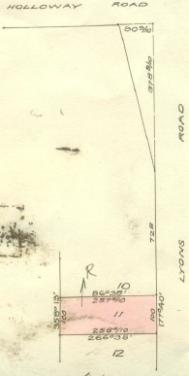3/6/1975 Transfer No. F719990 from Roderick Wayne Mc Gregor to **Rita Joy James** Married Woman and **Robin Leslie James** Gentleman both of 13 Gladys Grove Croydon.

3/6/1975 Mortgage No. F719991 to The National Bank of Australasia Limited, discharged 4/2/1977.

4/2/1977 Transfer No. G500206 from Rita Joy James and Robin Leslie James to **Robin Leslie James** Assistant Manager and **Jeanette Anne James** Married Woman both of 15 Olympus Drive North Croydon.

3/6/1975 Mortgage No. EG539323 to Knox Premier Building Society, discharged 11/9/1978.

9/5/1978 Caveat No. H66716 lodged. Caveat withdrawn 11/9/1978.

Plan of land in Certificate of Title Volume 8072 Folio 404.

11/9/1978 Transfer No. H228517 from Robin Leslie James and Jeanette Anne James to **Stephen James Hobson** Dental Mechanic and **Glenys Fay Hobson** Married Woman both of Flat 3 No. 604 Riversdale Road Camberwell.

11/9/1978 Mortgage No. H228518 to Commonwealth Savings Bank of Australia, discharged 4/2/1987.

4/2/1987 Transfer No. M682436R from Stephen James Hobson and Glenys Fay Hobson to **John Joseph O’Donoghue** of 31 Eden Ave. Heathmont.

4/2/1987 Mortgage No. M682437N to The Commissioners of The State Savings Bank of Victoria.

18/12/2001 Discharge No. X957743M of Mortgage No. M682437N lodged.

18/12/2001 Transfer No. X957744J from John Joseph O’Donoghue to **Walter Samuel White** and **Marie Ella White** both of 53 Lyons Road Croydon North Vic 3136.

4/3/2009 Transfer No. AG383383R from Walter Samuel White and Marie Ella White to **Li Chen** of 53 Lyons Road Croydon North Vic 3136.

4/3/2009 Mortgage No. AG8338784P to Westpac Banking Corporation lodged.

8/7/2016 Discharge No. AM923306C of Mortgage No. AG383384P lodged.

8/7/2016 Mortgage No. AM923307A to National Australia Bank Ltd lodged.

8/4/2022 Discharge No. AV516330X of Mortgage No. AM923307A lodged.

8/4/2022 Transfer No. AV516331V from Li Chen to **Yang Li** of 2 Felix Street Grovedale Vic 3216 and **Li Chen** of 53 Lyons Road Croydon North Vid 3136.

8/4/2022 Mortgage No. AV516332T to Westpac Banking Corporation lodged.