**History of Part of Crown Allotment 22F and Part 22G Parish Warrandyte – Yarra Road and Knees Lane**

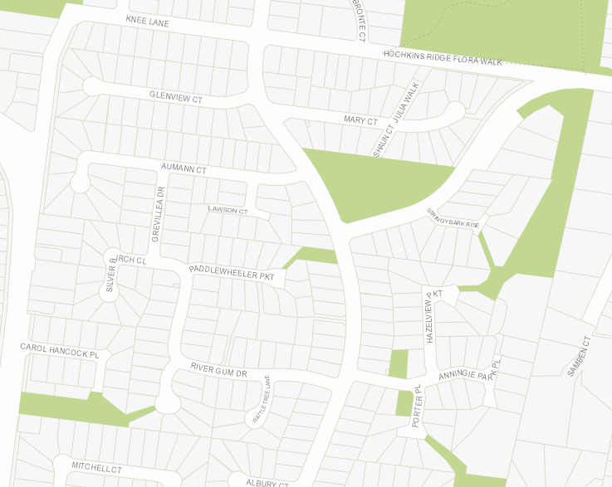**Crown Grant Volume 1052 Folio 261**, area 28 acres and 19 perches, being (Crown) Allotment 25F in the Parish of Warrandyte County of Evelyn in consideration of thesum of Thirty nine pounds issued **to Andrew Welch Stewart** of Warrandyte.

Plan of land in Crown Grant Volume 3468 Folio 421.

Plan showing current property boundaries of land in Crown Allotment 22F and part of Crown allotment 22G.

16/9/1878 Mortgage No.26413 to The Land Credit Bank of Australasia Limited.

13/3/1916 Memo No. 4504. Copy Writ of fieri Facias issued out of the Supreme court in an Action No. 5679 Richard Hampton Kings against Andew Stewart otherwise Andrew Welch Stewart served on the 10th day of January 1879.

7/4/1879 Transfer No.77733 by Robert Ride as Sheriff to **Richard Tamplin Kings.**

*******************************************************************

**Certificate of Title Volume 1099 Folio 771**

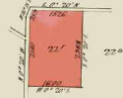7/4/1879 Certificate of Title Volume 1099 Folio 771, area 38 acres and 19 perches, being Crown allotment 22F subject to a Mortgage from Andew Welch Stewart to The Land Credit Bank of Australasia Limited registered the 16th day of September 1878 and numbered 26413 in the Register Book (which Mortgage was discharged 15/7/1879) issued to **Richard Tamplin Kings** of Lillydale Butcher.

Plan of land in Certificate of Title Volume 1099 Folio 771

29/7/1879 Transfer No. 79957 to **Thomas Knee**.

***************************************************************************

**Certificate of Title Volume 1121 Folio 165**

29/7/1879 Certificate of Title Volume 1121 Folio 165, area 38 acres and 19 perches, being

Crown Allotment 22F issued to **Thomas Knee** of Doncaster Wood Carter.

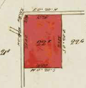12/6/1922 Red Ink No. 2261622. Thomas Knee died on 4th July 1920. Probate has been granted to (two of his sons) **Thomas Samuel Knee** and **Edwin John Knee** both of Yarra Road Croydon Orchardists.

12/6/1922 Red Ink No. 2261623. Certificate of Title Cancelled see Certificate of Title Vol. 4664 Fol. 787.

**************************************************

Plan of land in Certificate of title Volume 1121 Folio 165.

**Crown Grant Volume 1270 Folio 852**

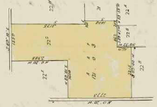28/4/1881 Crown Grant Volume 1270 Folio 852, area 121 aces and 3 perches, being (Crown) allotment 22G, in consideration of One hundred and twenty two pounds, issued to **Thomas James Piece** of Warrandyte Farmer.

22/7/1887 Mortgage No. 44649 to George Alexander.

15/10/1881 Memo No. 7844. Copy writ of Fieri Facias issued out of the Supreme Court in an action No. 3059 William R Bennetts and Ann Bennetts against James Pierce served on the 15th day of October 1881. This writ has been satisfied 15/12/1881.

15/12/1881 Transfer No. 100113 from Thomas James Pierce to **George Alexander**,

Plan of land in Crown Grant Volume 1270 Folio 852.

***********************************************************************

**Certificate of Title Volume 1312 Folio 229**

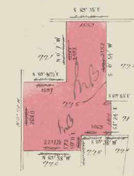15/12/1881 Certificate of Title Volume 1312 Folio 229, area ~~121 acres and 3 perches~~ 118 acres 3 roods and 6 perches, being Crown Allotment 22G issued to **George Alexander** of Number 102 Bridge Road Richmond Pawnbroker.

14/12/1898 ??? No. 13677 **Simon George Alexander** of “Howlands: Docker and Gipps Streets Commercial Traveller **Moses Alexander** of Bridge road Pawnbroker and **Sophia Alexander** “Howlands” Docker and Gipps Streets Widow all of Richmond are registered as the proprietors of the within described land as Executors and Executrix of the will of George Alexander who died on the 30th March 1892 was granted on the 12th June 1982. N.B. Sophia Alexander is registered as Executrix during her widowhood only.

Plan of land in Certificate of Title Volume 1312 Folio 229

10/12/1901 Memo No. 4330. Pursuant to the direction of the Commissioner of Titles in this behalf given under the 229nd Section of The Transfer of Land Act 1890 the above-named **Simon George Alexander** and **Moses Alexander** are registered sole proprietors of the within land as Surviving Executors of the Will of George Alexander deceased.

20/1/1902 Transfer No. 449169 from Simon George Alexander and Moses Alexander to **Simon George Alexander** of 97 Dundas Place Albert Park and **Moses Alexander** of Bridge Road Richmond both Pawnbrokers and **John Alexander** of Bridge Road Richmond Clerk as Executors of the will of George Alexander deceased.

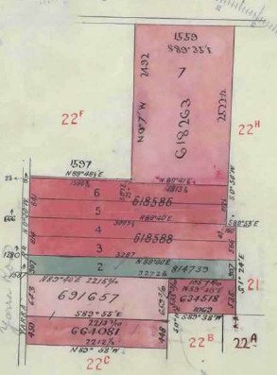9/8/1905 Memo No. 6154. Pursuant to the direction of the Commissioner of Titles in this behalf given under the 229th Section of the Transfer of Land Act 1890, **Moses Alexander** and **John Alexander** are registered sole proprietors of the within land as surviving Executors of the will of George Alexander deceased.

12/4/1910 Transfer as to part No. 618586 from Moses Alexander and John Alexander to Francis McGivern, area 19 acres 1 rood and 2 perches, new Certificate of Title Volume 3409 Folio 627.

12/4/1910 Transfer as to part No. 618588 from Moses Alexander and John Alexander to John Roberts, new Certificate of Title Volume 3409 Folio 628.

20/4/1910 Transfer as to part No. 618263 from Moses Alexander and John Alexander to Thomas Knee, area 39 acres 1 rood and 8 perches, new Certificate of title Volume 3413 Folio 418.

21/10/1910 Transfer as to Part No. 634518 from Moses Alexander and John Alexander to Frank Turner and Edward White, area 5 acres 2 roods and 31 perches, new Certificate of Title Volume3475 Folio895.

Plan attached to Certificate of title showing lands transferred out.

9/10/1911 Transfer as to part No. 664081 from Moses Alexander and John Alexander to William White, area 9 acres 3 roods and 30 perches, new Certificate of Title Volume 3540 Folio 965.

5/8/1912 Transfer as to part No. 691657 from Moses Alexander and John Alexander to William White, area 14 acres 1 rood and 27 perches, new Certificate of Title Volume 3626 Folio028.

22/11/1916 Transfer as to balance No. 814739 691657 from Moses Alexander and John Alexander to Herbert Charles Gill, new Certificate of Title Volume 4008 Folio 546.

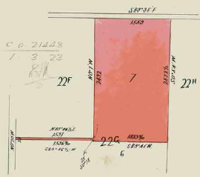 ***********************************************************************

**Certificate of Title Volume 3413 Folio 418**

20/4/1910 Certificate of Title Volume 3413 Folio 418, area 39 acres 1 rood and 8 perches, being Lot 7 on Plan of Subdivision No. 5187 and being part of Crown Allotment 22G issued to **Thomas Knee** of Yarra Road Croydon Farmer.

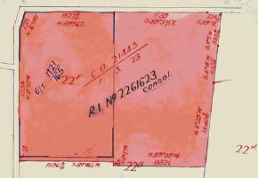12/6/1922 Red Ink No. 2261622. Thomas Knee died on 4th July 1920. Probate has been granted to **Thomas Samuel Knee** and **John Knee** both of Yarra Road Croydon Orchardists.

Plan attached to Certificate of Title Volume 3413 Folio 418 showing consolidation of hte 2 parcels of land.

Plan of land in Certificate of Title Volume 3413 Folio 418.

12/6/1922 Red Ink No. 2261623. Certificate of Title Cancelled. See Certificate of Title Volume 4664 Folio 787.

********************************************************************

**Certificate of Title Volume 4664 Folio 787**

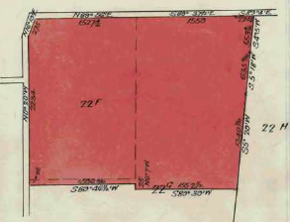12/6/1922 Certificate of Title Volume 4664 Folio 787, area 82 acres 2 roods and 24¼ perches, being Crown Allotment 22F and part of Crown Allotment 22G issued to **Thomas Samuel Knee** and **Edwin John Knee** both of Yarra Road Croydon Orchardists. (this amounts to a consolidation of the lands in Certificates of Title Volume 1121 Folio165 and Volume 3413 Folio 416).

22/5/1923 Transfer as to part and Creation of Easement No. 1105707 to (their mother) Sarah Knee, new Certificate of Title Volume 4750 Folio 997.

Plan attached to Certificate of Title Volume 4664 Folio 787.

22/5/1923 Transfer as to part and Creation of Easement No. 1105708 to (their brother) Oliver Leslie Knee, new Certificate of Title Volume 4750 Folio 998.

30/5/1923 Transfer as to part and Creation of Easement No.1105709 to Edwin John Knee, new Certificate of Title Volume 4750 Folio 999.

30/5/1923 Transfer as to balance and Creation of Easement No.1105710 to William George Knee, new Certificate of Title Volume 4750 Folio 000.

****************************************************************************

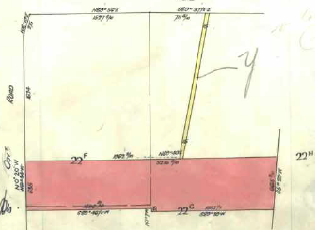**Certificate of Title Volume 4750 Folio 997**

22/5/1923 Certificate of Title Volume 4750 Folio 997, area 20 acres 2 roods and 27 perches, being part of Crown Allotments 22F and 22G (after Transfer and Creation of Easement No. 1105707 by Thomas Samuel Knee and Edwin John Knee issued to (their mother) **Sara Knee** of Yarra Road Widow.

18/2/1933 Transfer No. 1518221 from Sarah Knee to (her son) **Oliver Leslie Knee** of Yarra Road Croydon Orchardist.

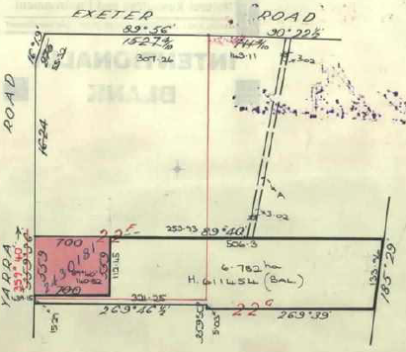22/8/1951 Transfer as to part No.2430181 to Myrtle Evelyn Pearson, area 3 acres 3 roods and 26 perches, new Certificate of Title Volume 7606 Folio 177.

Plan of land in Certificate of Title Volume 4750 Folio 997.

??/11/1952 Mortgage No. 102627 to The National Bank of Australasia, discharged 30/12/1954.

13/7/1973 Caveat No. E898613 lodged. Caveat withdrawn 22/6/1979.

2/6/1976 Transmission Application No. G174531. Oliver Leslie Knee died on 22nd February 1975. Probate of his Will has been granted to **Ruby Alice Knee** Widow and **Richard Oliver Knee** Orchardist both of Yarra Road Croydon.

Plan of land attached to Certificate of Title Volume 4750 997 showing land transferred out.

16/8/1978 Caveat No. H194428 lodged. Caveat lapsed 13/9/1979.

19/4/1979 Caveat No. H406944 lodged. Caveat lapsed 16/2/1980.

22/2/1979 Mortgage No. H570900 to The National Bank of Australasia Limited, discharged 20/7/1979.

20/7/1979 Survivorship Application No. H611453. Richard Oliver Knee is the surviving proprietor.

20/7/1979 Transfer as to balance No. H611454, new Certificate of Title Volume 9363 Folio 516.

**\*\*\*\*\*\*\*\*\*\*\*\*\*\*\*\*\*\*\*\*\*\*\*\*\*\*\*\*\*\*\*\*\*\*\*\*\*\*\*\*\*\*\*\*\*\*\*\*\*\*\*\*\*\*\*\*\*\*\*\*\*\*\*\*\*\*\*\*\*\*\*\***

**Certificate of Title Volume 4750 Folio 998**

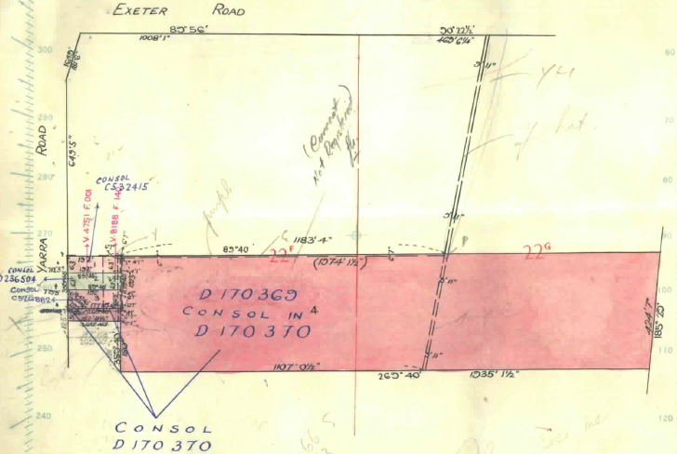22/5/1923 Certificate of Title Volume 4750 Folio 998, 20 acres 3 roods and 7 perches, being part of Crown allotments 22F and 22G together with a right of drainage over the land coloured blue on the said map and subject to the Drainage Easement created by Instrument of Transfer No. 1105707 in the Register Book (after Transfer and Creation of Easement No. 1105768 from Thomas Samuel Knee and Edwin John Knee) issued to **Oliver Leslie Knee** of Yarra Road Orchardist.

Plan of land in Certificate of Title Volume 4750 Folio 997

29/6/1923 Transfer as to part No. 1113016 to Edwin John Knee, new Certificate of Title Volume 4751 Folio 004.

11/11/1952 Mortgage No. 1020627 to The National Bank of Australasia Limited, discharged 30/12/1954.

Plan attached to Certificate of Title Volume 4750 Folio 998

28/3/1958 Transfer as to part No. A 503003, new Certificate of Title Volume 8188 Folio 140.

13/8/1959 Transfer as to part No. A796637, new Certificate of Title Volume 8240 Folio685.

Plan attached to Certificate of Title Volume 4750 Folio 998

1/6/1961 Transfer as to part No. B217215, new Certificate of Title Volume 8303 Folio 339.

26/8/1968 Transfer as to balance No. D170369, new Certificate of Title Volume 8744 Folio 853.

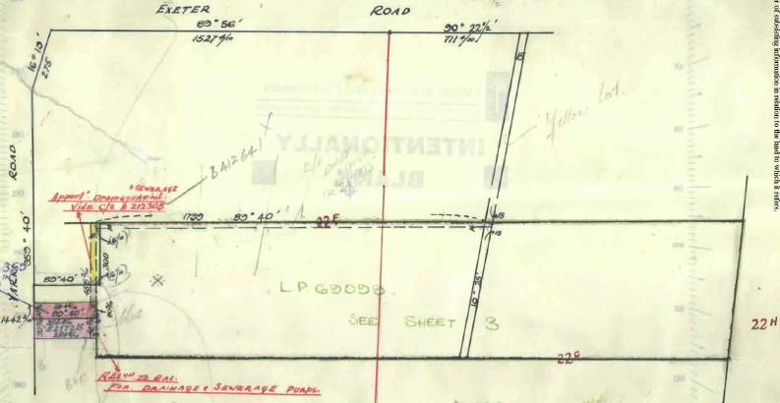*************

Plan attached to Certificate of Title Volume 4750 Folio 998.

**Certificate of Title Volume 4751 Folio 001**

29/6/1923 Certificate of Title Volume 4751 Folio 001, having a frontage of 300 links to Yarra Road by a depth of 200 links (approx. 0.60 of an acre), being part of Crown Allotment 22F (after Transfer No. 1113016 from Oliver Leslie Knee) issued to **Edwin John Knee** of Yarra Road Croydon Orchardist.

21/3/1958 Transmission Application No. A503001. Edwin John Knee died on 9 February 1957. Letters of Administration of his estate have been granted **Emma Mary Matilda Knee** of 12 Yarra Road Croydon Widow.

28/3/1958 Transfer No A503002 Emma Mary Matilda Knee (as Administratrix) to **Emma** **Mary Matilda Knee** of 12 Yarra Road Croydon Widow.

21/8/1958 Transfer No. A589828 from Emma Mary Matilda Knee to **William Wallace Ross** Orchardist and **Joyce Lorraine Ross** Married Woman both of 99 Tannock Street North Balwyn.

Plan of land in Certificate of title Volume 4751 Folio 001.

11/2/1959 Transfer No. A686367 from William Wallace Ross and Joyce Lorraine Ross to **Ruby Alice Knee** (widow of Oliver Leslie Knee) of 10 Yarra Road Croydon Widow.

8/3/1959 Mortgage No. A699629 to Rose Mary Allen, discharged 9/6/1966.

29/6/1966 Transfer as to Part No. C526882 (Lot3?), new Certificate of Title Volume 8646 Folio 568.

6/7/1966 Transfer as to part No. C532415 (Lot 1?), new Certificate of Title Volume 8661 Folio 001.

26/8/1968 Transfer as to part No. D170370, new Certificate of Title Volume 8744 Folio 853.

7/11/1968 Transfer as to balance No. D236504, new Certificate of Title Volume 8785 Folio 868.

***********************************************************************

**Certificate of Title Volume 8646 Folio 568**

29/6/1966 Certificate of Title Volume 8646 Folio 568 being Lot 3 on Plan of Subdivision No.69099 issued to **Arthur Benjamin Barley** Ceramics Worker and **Ruth Mary Barley** Married Woman both of 13 Yarra Road Croydon.

29/6/1966 Mortgage No. C526883 to Rose Mary Linda East, discharged 6/4/1978.

30/5/1988 Mortgage No. N485842R to Commonwealth Bank of Australia, discharged 4/8/1989.

26/1/1989 Survivorship Application No. N977316U by **Ruth Mary Barley** of 160 Yarra Road Croydon.

7/11/1994 Transfer No. T396663B from Ruth Mary Barley to **Timothy William Burslem** & **Jacqueline Anne Burslem** of 160 Yarra Road Croydon 3136.

7/11/1994 Mortgage No. T396664X to National Australia Bank Limited, discharged 24/2/1998.

Plan of land in Certificate of Title Volume 8646 Folio 568.

24/2/1998 Mortgage No. V281268L to Citibank Limited.

21/11/2001 Discharge No. X898264Y of Mortgage No. V281268L lodged.

21/11/2001 Transfer No. X898265V from Timothy William Burslem and Jacqueline Anne Burslem, Consideration $303,000.00 to **Martin Bruce Gash** and **Elvie Carne McInerney** both of 160 Yarra Road Croydon 3136 as joint proprietors for their joint lives and the life of each of them and the said **Martin Bruce Gash** and **Elvie Carne McInerney** as proprietors as Tenants in Common in equal shares of an estate in fee simple in remainder expectant. New Certificates of Title Volume 10662 Folios 770 & 771.

*****************************************************************************

**Certificate of Title Volume 10662 Folio 770**

21/11/2001 Certificate of Title Volume 10662 Folio 770 (No CofT exists created by Instrument No. X898265V) being Lot 3 on Plan of subdivision No. 69099 issued to Estate Life for the joint lives and the lives of each **Martin Gash and Elvie Carne Gash** both of 160 Yarra Road Croydon Vic 3136.

Certificate of Title Cancelled see Certificate of Title Volume 11053 Folio 832.

******************************************************************************

**Certificate of Title Volume 10662 Folio 771**

21/11/2001 Certificate of Title Volume 10662 Folio 771 being Lot 3 on Plan of Subdivision No.

69099 (after Transfer No. X898265V from Timothy William Burslem and Jacqueline Burslem) issued as an estate Fee simple in Remainder Expectant upon the determination of an estate for the joint lives and lives of each of Martin Bruce Gash and Elvie Carne McInerney as Tenants in Common as to 1 of a total of 2 equal undivided shares **Martin Bruce Gash** of 160 Yarra Road Croydon Vic 3136 and as to 1 of a total of 2 equal undivided shares **Elvie Carne McInerney** of 160 Yarra Road Croydon Vic 3136.

21/11/2001 Mortgage No. X898266S to Commonwealth Bank of Australia lodged.

30/9/2003 Discharge No. AC372291T of Mortgage No. X898266S lodged.

20/12/2004 Mortgage & Change of Registered Proprietor Name No. AD321719K. Mortgage to Commonwealth Bank of Australia. Proprietorship: Estate Life: For the Joint lives and the lives of each **Martin Gash** and  **Elvie Carne Gash** both of 160 Yarra Road Croydon Vic 3136 (and as) Tenants in Common as to 1 of a total of 2 equal undivided shares **Martin Bruce Gash** of 160 Yarra Road Croydon Vic 3136 and as to 1 of a total of 2 equal undivided shares **Elvie Carne Gash** of 160 Yarra Road Croydon Vic 3136.

14/2/2008 Discharge No. AF650122T of Mortgage No. AD321719K lodged.

14/2/2008 Certificate of Title Cancelled by Transfer No. AF650122T.

******************************************************************************

**Certificate of Title Volume 11053 Folio 832**

14/2/2008 Certificate of Title Volume 11053 Folio 832, being Lot 3 on Plan of subdivision No. 69099 (after Transfer No. AF650122T from Martin Bruce Gash and Elvie Carne Gash) issued to **Justin Gioffre** and **Catrina Gioffre** both of 160 Yarra Road Croydon Vic 3136.

18/5/2010 Mortgage No. AH230861D to Commonwealth Bank of Australia lodged.

4/8/2010 Certificate of Title Cancelled by Plan of subdivision No. 626371X.

*****************************************************************************

**Certificate of Title Volume 11220 Folio 372**

12/8/2010 Certificate of Title Volume 11220 Folio 372, being Lot 1 on Plan of Subdivision No. 626371X issued to **Justin Gioffre** and **Caterina Gioffre** both of 160 Yarra Road Croydon subject to Mortgage No. AH230861D to Commonwealth Bank of Australia.

7/6/2012 Transfer No. AJ713948G from Justin Gioffre and Caterina Gioffre to **Caterina Gioffre** of 160 Yarra Road Croydon North Vic 3136.

Plan of Subdivision No. 626371X

14/3/2014 Discharge No. AK963030K of Mortgage No. AH230861D lodged.

14/3/2014 Transfer No. AK963031H from Caterina Gioffre to **Monica Maia Janczak** of 160 Yarra Road Croydon North Vic 3136.

14/3/2014 Mortgage No. AK963032F to Australia and New Zealand Banking Group Ltd lodged.

2/2/2016 Discharge No. AM522926F of Mortgage No. AK963032F lodged.

2/2/2016 Mortgage No. AM522927D to Police Financial Services Ltd lodged.

******************************************************************************

**Certificate of Title Volume 8188 Folio 140**

28/3/1958 Certificate of Title Volume 8188 Folio 140 being part of Crown Allotment 22F (after Transfer as to part No. A503003 from Oliver Leslie Knee) issued to Emma Mary Matilda Knee of 12 Yarra Road Croydon.

21/8/1958 Transfer No. A589828 from Emma Mary Matilda Knee to **William Wallace Ross** Orchardist and **Joyce Lorraine Ross** Married Woman both of 99 Tannock Street North Balwyn.

11/2/1959 Transfer No. A686367 from William Wallace Ross and Joyce Lorraine Ross to **Ruby Alice Knee** (widow of Oliver Leslie Knee) of 10 Yarra Road Croydon Widow.

Plan attached to Certificate of Title Volume 8188 Folio showing Easement No. B212305

Plan of land in Certificate of Title Volume 8188 Folio 140.

8/3/1959 Mortgage No. A699629 to Rose Mary Allen, discharged 9/6/1966.

24/5/1961 Creation of Easement No. B212305.

29/6/1966 Transfer as to Part No. C526882 (Lot3?), new Certificate of Title Volume 8646 Folio 568.

6/7/1966 Transfer as to part No. C532415 (Lot 1?), new Certificate of Title Volume 8661 Folio 001.

26/8/1968 Transfer as to part No. D170370, new Certificate of Title Volume 8744 Folio 853.

7/11/1968 Transfer as to balance No. D236504, new Certificate of Title Volume 8785 Folio 868.

******************************************************************************

**Certificate of Title Volume 4750 Folio 000**

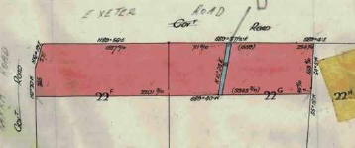30/5/1923 Certificate of Title Volume 4750 Folio 000, area20 acres 2 roods and 30 perches, being part of Crown Allotments 22F and 22G subject to on the land coloured blue Any Easements affecting the same (after Transfer and Creation of Easement No.1100710 from Thomas Samuel Knee and Edwin John Knee) issued to **William George Knee** of Yarra Road Croydon Orchardist.

20/9/1957 Transfer as to part No. A406558, area 10 acres 3 roods and 0 perches, new Certificate of Title Volume 8154 Folio 914.

Plan of land in Certificate of Title Volume 4750 Folio 000

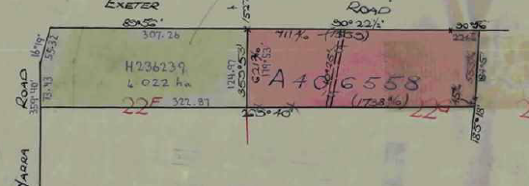15/4/1973 Mortgage No. E778246 to The National Bank of Australasia Limited, discharged 15/12/1976.

9/7/1977 Transmission Application No. G700242. William George Knee died on 20th November 1976. Probate of his Will has been granted to **Frederick James Knee** of Dudley Road Wonga Park Orchardist and **Peter George Knee** of Exeter Road Croydon Orchardist.

Plan attached to Certificate of Title Volume 4750 Folio 000 showing lands transferred out.

15/9/1978 Transfer as to balance No. H236239, new Certificate of Title Volume 9307 Folio 582.

**********************************************************************

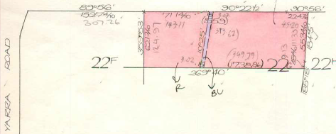**Certificate of Title Volume 8154 Folio 914**

20/9/1957 Certificate of Title Volume 8154 Folio 914, area10 acres and 3 roods, being part of Crown allotment 22G (after Transfer No. A406558 from William George Knee) issued to (his son) **Peter George Knee** of Yarra Road Croydon Orchardist.

Plan of land in Certificate of Title Volume 8454 Folio 914

18/12/1962 Mortgage No. B568375 to E. S. & A. Savings Bank Limited, discharged 8/2/1973.

9/8/1976 Mortgage No. G269506 to Australia and New Zealand Banking Group Limited, discharged 3/10/1988.

8/4/1983 Mortgage No. 324003 to Rural Finance Commission, discharged 13/?/19??.

2/11/1988 Caveat No. N809252U lodged. Caveat transferred to new C/T’s.

12/4/1989 Certificate of Title Cancelled. The following titles have been issued Pursuant to Regulation 10 of the Transfer of Land Act: Lots A & B in Vol 9871 Fol 343 and in Vol 9871 Fol 344.

*************************************************************************

**Certificate of Title Volume 9307 Folio 582**

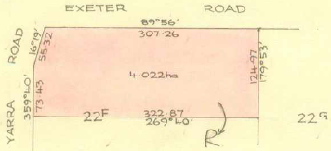15/9/1978 Certificate of Title Volume 9307 Folio 582, area 4.022 hectares, being part of Crown Allotment 22F (after Transfer No. H236239 from Frederick James Knee and Peter George Knee) issued to **Peter George Knee** Orchardist as to Nine equal undivided tenth parts or shares and **Miriam Knee** spinster as to one equal undivided tenth part or share both of Exeter Road Croydon.

Plan of land in Certificate of Title Volume 9307 Folio 582.

29/3/1983 Mortgage No. K314766 as to the interest of Peter George Knee to Rural Finance Commission, discharged 13/10/1988.

2/11/1988 Caveat No. N809253R lodged. Caveat will lapse on registration of P243723T.

8/6/1989 Transfer No. P243723T from Peter Geroge Knee and Miriam Knee to **Yarra Views Estate Pty. Ltd.** of 329 Mitcham Road Mitcham.

8/6/1989 Mortgage No. P243724Q to St. George Commercial Credit Corporation Limited, discharged 5/3/1990.

5/3/1990 Transfer No. P689802V from Yarra View Estate Pty. Ltd. to **Furlonger Pty. Ltd.** of 1053 Doncaster Rd. Doncaster.

5/3/1980 Mortgage No. P689803S to National Australia Bank Limited, discharged 17/10/1991.

20/3/1991 Caveat No. R265127Q by James Ciaran O’Sullivan as purchaser. Caveat withdrawn 28/8/1991.

19/7/1991 Caveat No. R445890S by Group Associates Investments Pty. Ltd. as purchaser lodged. Caveat will lapse upon registration of R596819U.

17/10/1991 Transfer No. R596819U from Furlonger Pty. Ltd. to **Group Associates Investments Pty. Ltd.** of 153 Eley Rd. Blackburn South.

17/10/1991 Mortgage No. R596820U to Australian Guarantee Corporation Limited. Res 1 & 2 On Plan PS 312889G Is freed and discharged from this mortgage pursuant to Section 24 Subdivision Act 1988 registered 18/3/1992.

18/3/1992 Certificate of Title Cancelled Pursuant to Section 24 subdivision Act 1989 and Titles issued as set out hereunder PS 319889G. Lots One to 32 in Vol 10059 Fol 225 to Vol 10059 Fol 256, Lot A in Vol 10059 Fol 257 and Reserve One to 2 in Vol 10059 Fol 258 to Vol 10059 to Fol 259.

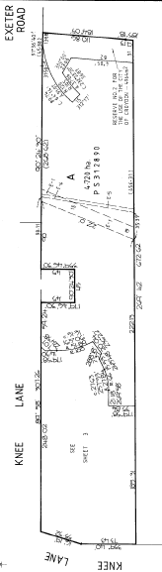

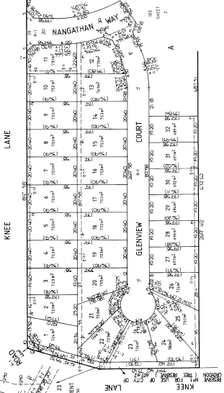

Plan of Subdivision No. 312889G

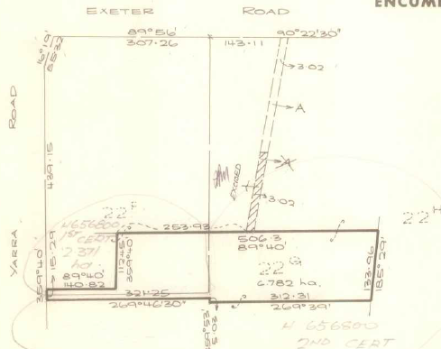**Certificate of Title Volume 9363 Folio 546**

20/7/1979 Certificate of Title Volume 9363 Folio 546, area 6.782 hectares, being part of Crown allotments 22F and 22G (after Transfer No. H611484 from Richard Oliver Knee) issued to **A.G. and H. Hams Pty. Ltd.** of “Anningie Park” Yarra Road Croydon.

24/8/1979 Certificate of Title Cancelled application No. H656800 See Vol. 9337 Fol. 274 and Vol. 9377 Fol. 275.

Plan of Land in Certificate of Title Volume 9363 folio 546