How two special birds made a community very happy.
In a lovely tree lined street, there was an enormous black wattle tree. It was the tallest tree along the nature strip, but it had grown like co-joined twins. This is called bifurcation, and can make the tree weak at the bottom.
As the tree grew it caused a bump in the street with a very large root. The Local Council wanted to cut it down, but the lady who lived in the house behind it, asked them to leave it alone, saying it was a cheap speed hump!
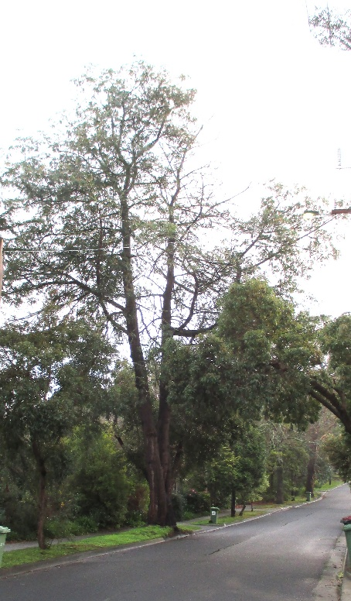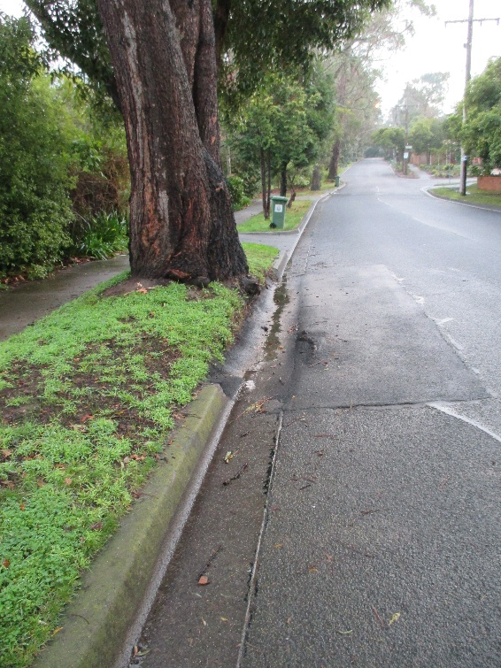
She also asked Council to remove the concrete edge of the road, so that the water did not pool into a big puddle for the neighbour. To her great surprise, they did this too and all was well.
One night in a big thunderstorm, lightening hit the top of the tree on one half, which made the tree send out a big side branch across the road. No one noticed this had happened, but the tree began to become unhealthy and started splitting into its two halves at the base.
When she realised the tree was unsafe the lady sadly called the Council saying the tree would now have to go as it was quite possibly dangerous. Her neighbour had called her out to watch the gap widening as the wind blew, so there really was no other choice now.
The electricity company arrived with about 3 trucks, a mulcher and a cherry picker and another for the waste. Before starting work the electricity company made sure that the power was cut, because they were worried about the tree falling on the lines. They began working at 8 pm that night and had blacked out over 600 houses, in the area. In howling wind and rain the men began to chop the tree into pieces, using a very loud mulcher for the leaves and small branches. They did not stop until 2am in the morning, when everyone who had not been able to sleep, was glad to get some rest from the noise.

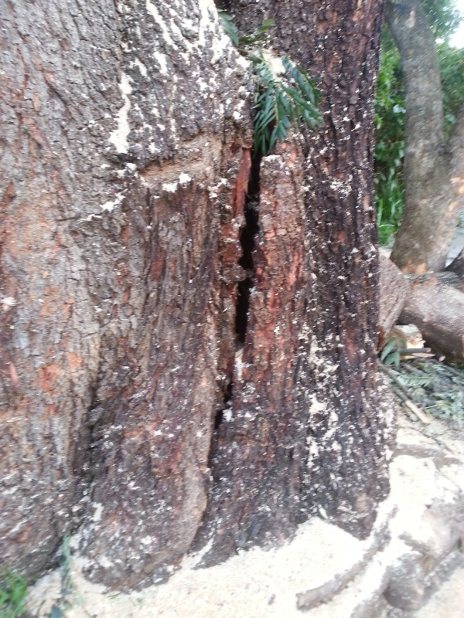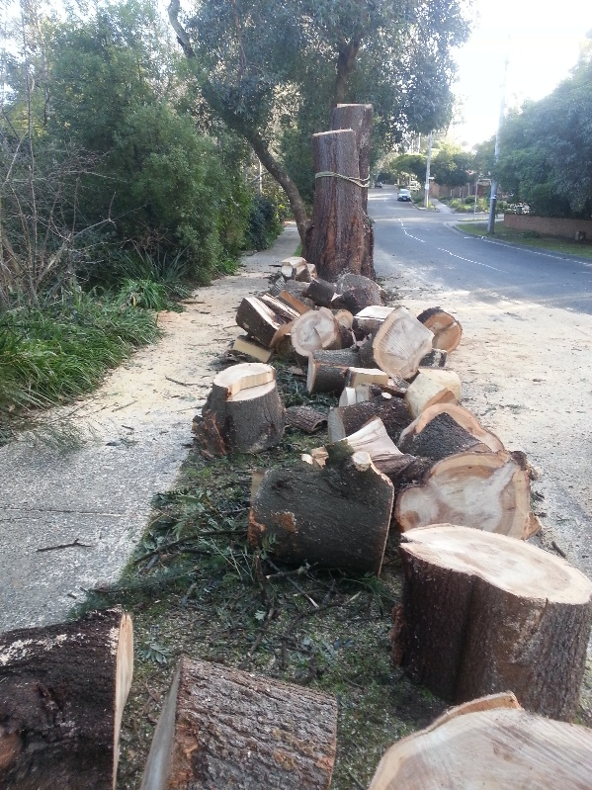
Neighbours stopped by to take the wood home for firewood. Everyone was interested to know why the tree had to be cut down. The two halves of the tree were left standing for quite a long time.
Then one day the lady who lived in the house had a bright idea, that maybe they could be carved into something instead of just standing there as dead stumps. She asked the Council, and they told her that she would have to make an application to their Arts and Culture department. She gave it some thought and decided to try and see what might happen. After asking for an Arts grant, some people from Council came out to visit and commented on what a beautiful street and area it was. Seeing that many people walked past with dogs, or children going to school, it seemed like a great idea, to make a carving of some kind.
She had to wait about another year for Council to have the money for this artwork, and so eventually a chainsaw artist was engaged. When Rob, the artist visited the site, he walked around for a bit looking at the shape and position of the stumps. Then when inspiration set in he stripped the tree of bark feeding the underlying grubs to the local magpies.
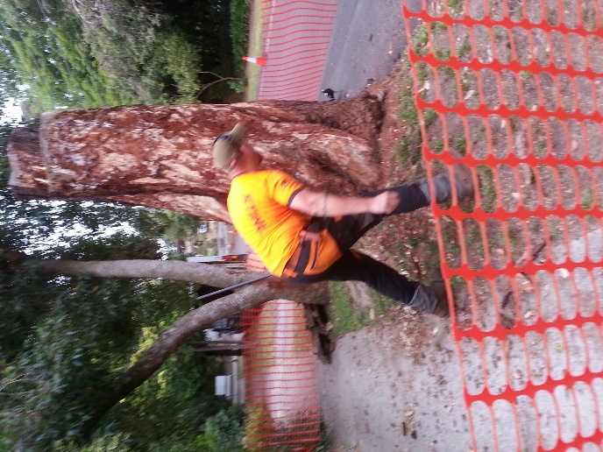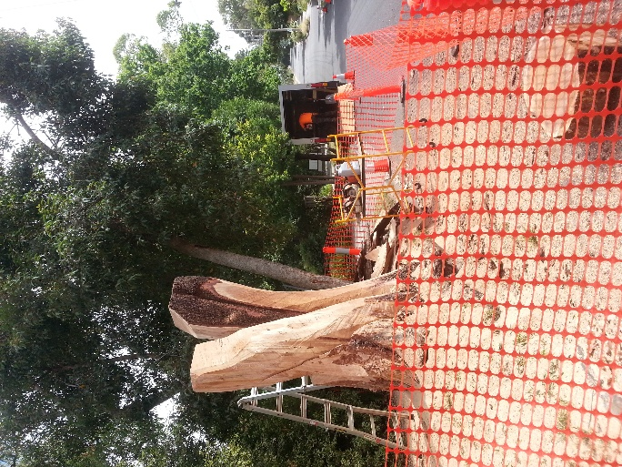

He brought a van which is his mobile shed. Inside it was like a well kept workshop with a work bench on one side for sharpening his chains, or fixing them if they broke. On the wall he had about 10 different sized chainsaws. A really long one, then many different sizes all the way down to a tiny weeny one, used for fine work, which he used for the feathering effect. 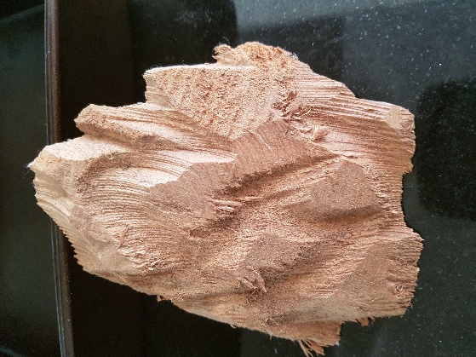
The project took only 4 days for him to create these birds. He worked fast and with an expert eye for the image in his head to become the sculpture.
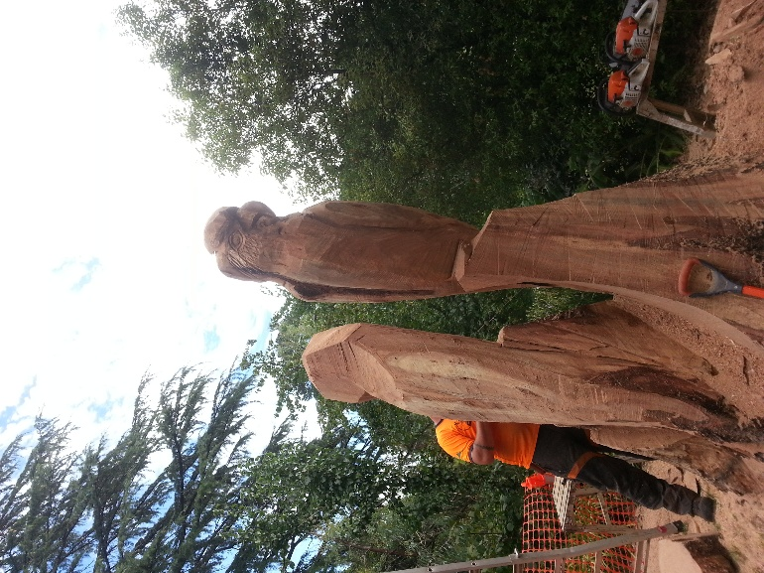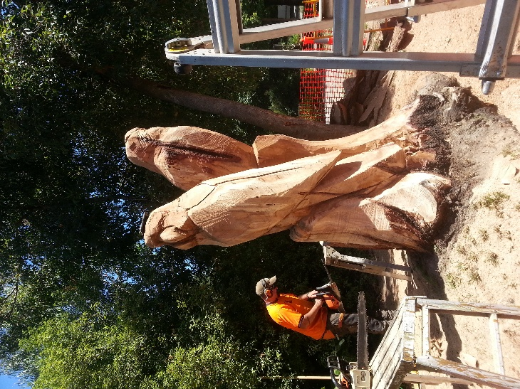
He kept cutting, shaping, standing to look, sharpening his chains and rested his mobile phone of the head of one of the birds, you might just make it out as a black line. Anyone who drove along the street to collect their children from school slowed right down to see how they were coming along. The neighbours walked up to it each evening to check on progress. People began to talk to each other and start being interested in who lived where and who they knew in common. Every evening there was a small crowd of happy talkative people.
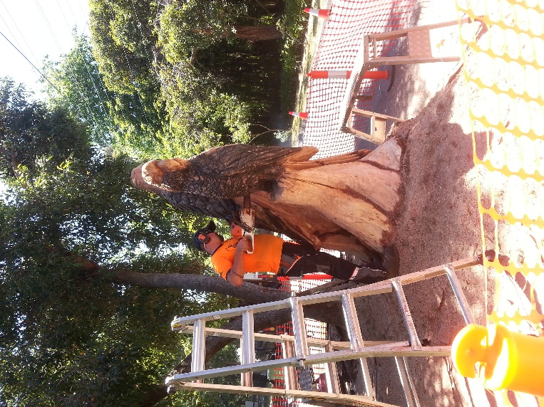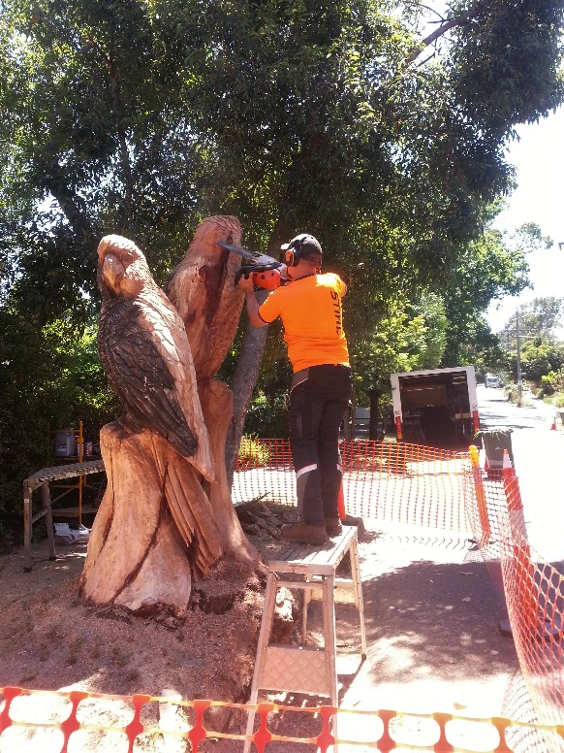
The birds began to fascinate the neighbourhood and everyone was excited to see how beautiful they were. Rob cleverly made one look in one direction, while the back one looked the opposite way, so no matter which way you walked up to them, one of them was looking at you.
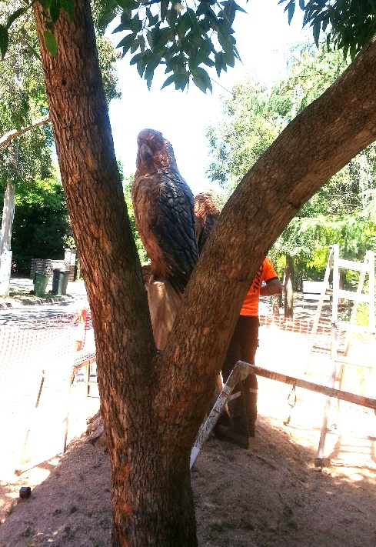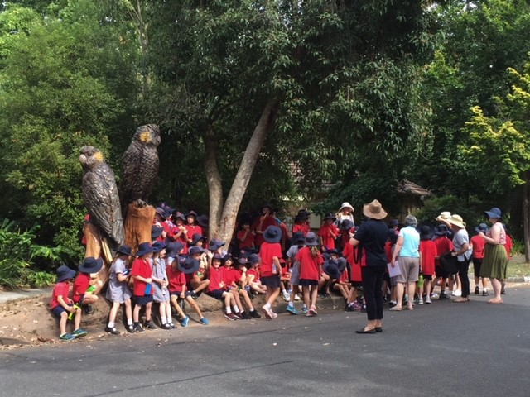
When they were finished the school children came to visit the cockies and hear about how the tree had been struck by lightning and how much the neighbours loved seeing them.
Delivery drivers who did not know this street, would stop and look, the rubbish truck driver stopped for a photo. Many people visited the cockies, including some people visiting families for Christmas. After lunch they would be taken for a walk to see the birds, and many photos went overseas with the visitors when the went home. If the lady in the house was out the front, and saw anyone looking she offered to take a photo of them with the birds.
After the 4 days of carving, the lady bought a huge Thank You card, and set it up near the cockies asking people if they would like to thank Council in writing. There were so many beautiful comments, it was necessary to put another sheet of paper into the card so there were four pages for people to say thank you.
The very next Monday, the lady took the card to Council and gave it to the Chief Officer, and another officer who had known about the project. They were delighted to read all the lovely comments putting big smiles on their faces too.
A few weeks later a neighbour from up the road, knocked on the lady’s front door, her husband had taken some of the wood and had made two pens from the wood, so they would always have a piece of it. This was yet another act of kindness and community connection.

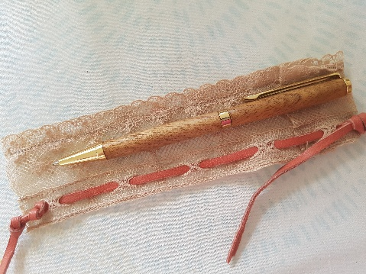
Even a dead tree can create magic. So many people in the area, talk to each other now that they have met. Children would leave easter eggs at the feet of the cockies, sometimes flowers too and once a small birds nest was placed at their feet. These birds became an invisible web of the community. They even got their own street sign.
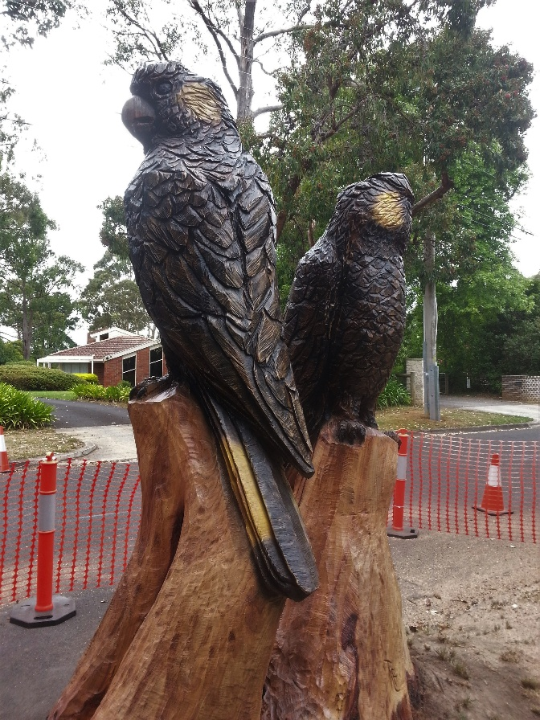
The Yellow Tailed Black Cockatoos of Long View Rd in South Croydon.

